Subject line: Coming soon! An updated commuter benefit for Commonwealth of MA employees
Preview text: Watch your inbox for more information about your new benefit.
Audience: All eligible employees
From: [DEPARTMENT Payroll Team]
Timing: November 2 or 3

Hi [First Name],

The Commonwealth of Massachusetts is introducing a new and improved commuter benefit in partnership with Jawnt. Starting mid-November, you'll be invited to enroll in Jawnt Pass, a modern commuter debit card that helps you save money while getting to work.

What is Jawnt Pass?
Jawnt Pass is a mobile-friendly debit card that you can load with pre-tax dollars to pay for transit or parking. Think of it like an HSA or FSA, but for commuting. You can use it just like any other debit card: buy your monthly transit pass, tap to pay at the station, use it at the parking garage, or load it to your mobile wallet for a fully contactless experience.

Please note: Jawnt is replacing the previous benefit provider, Voya.

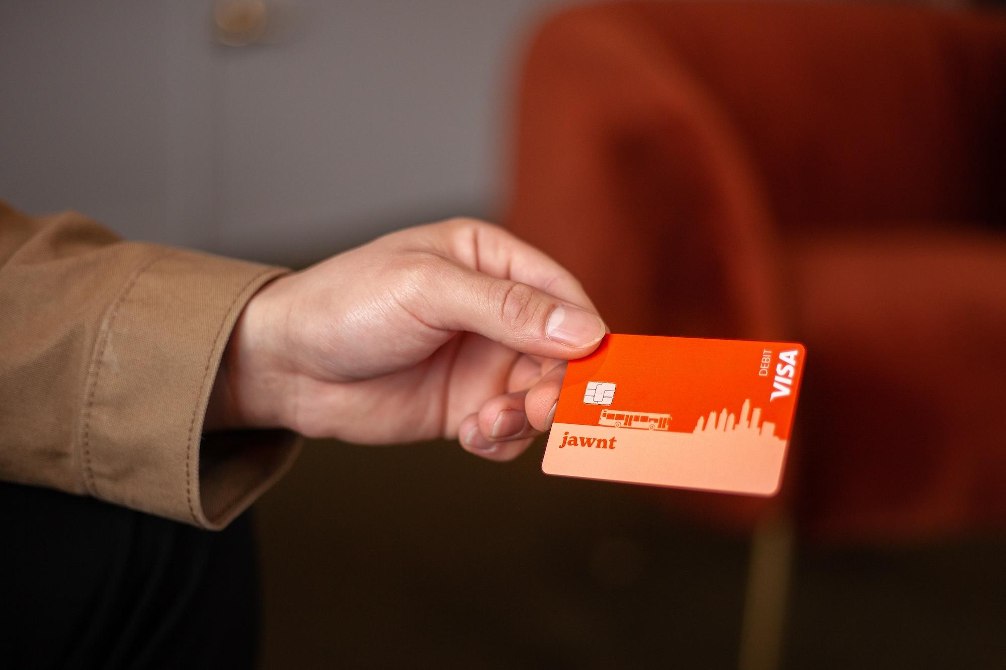

How much can I save?
Commuter benefits let you set aside pre-tax dollars to pay for your commute, meaning you save money on your taxes just by getting to and from work. The exact savings depend on your tax bracket, but most people save around 30% on eligible commuting expenses compared to paying out of pocket. Some Commonwealth of MA departments offer an additional subsidy on eligible expenses, so you save even more. Find out if your department is eligible here.

Where can I use it?
Your Jawnt Pass works with all local transit agencies and platforms, including the MBTA (subway, bus, boat, and commuter rail), Regional Transit Authorities, and Amtrak. It also works for eligible parking expenses, including office garages, lots, transit station parking, and your SpotHero commuter parking account.

I already have a monthly MBTA pass. Do I need to enroll in Jawnt Pass?
If you use a monthly transit pass, we still recommend enrolling in Jawnt Pass so that you can enjoy more flexible savings. For example, you could use your Jawnt Pass to purchase a monthly transit pass, and you could also use it to pay for parking at the station. For months you don’t commute as much, you could use it to pay for single rides on transit instead, all with pre-tax savings.
For more information about how it works, visit the Jawnt Enrollment Guide.
Next steps
Watch your email over the coming weeks for important details and next steps. When your enrollment invite arrives, setup only takes a few minutes.

- November 10 - You'll receive an invitation to enroll
- December 3 - Deadline to enroll for January benefits
- December 21 - Jawnt Pass loaded and ready to use!

In the meantime, feel free to reach out to [HR/Benefits contact name or email] with any questions.

Happy commuting!
[DEPARTMENT Payroll Team]

